# **AVACADO PROJECT**

Problem Statement:

**Avocado is a fruit consumed by people heavily in the United States.**

### Content

This data was downloaded from the Hass Avocado Board website in May of 2018 & compiled into a single CSV.

The table below represents weekly 2018 retail scan data for National retail volume (units) and price. Retail scan data comes directly from retailers’ cash registers based on actual retail sales of Hass avocados.

Starting in 2013, the table below reflects an expanded, multi-outlet retail data set. Multi-outlet reporting includes an aggregation of the following channels: grocery, mass, club, drug, dollar and military. The Average Price (of avocados) in the table reflects a per unit (per avocado) cost, even when multiple units (avocados) are sold in bags.

The Product Lookup codes (PLU’s) in the table are only for Hass avocados. Other varieties of avocados (e.g., green skins) are not included in this table.

Some relevant columns in the dataset:

* Date - The date of the observation
* Average Price - the average price of a single avocado
* type - conventional or organic
* year - the year
* Region - the city or region of the observation
* Total Volume - Total number of avocados sold
* 4046 - Total number of avocados with PLU 4046 sold
* 4225 - Total number of avocados with PLU 4225 sold
* 4770 - Total number of avocados with PLU 4770 sold

1.Problem Definition:

Avocado price data includes observations from 2015 to 2018 and was originally extracted from Avacado project and downloaded the dataset covers the .csv files average prices, types (conventional or organic), and cities and regions where avocados were sold.The goal is to predict the average price which is continuous in nature of the different type of avocado and using the region that in which region they are lying.

# 2. Data Analysis:

# Data Preparation and Cleaning

* Reading the CSV file and doing initial statistical analysis (shape, values etc)
* Data Pre-processing: Reading the unique values for each column and removing those which won’t be significant in the analysis further.
* Create a new data frame to proceed with the analysis further

Dataset contains

* Date — The date of the observation
* Average Price — the average price of a single avocado
* type — conventional or organic
* year — the year
* Region — the city or region of the observation
* Total Volume — Total number of avocados sold
* 4046 — Total number of avocados with PLU 4046 sold
* 4225 — Total number of avocados with PLU 4225 sold
* 4770 — Total number of avocados with PLU 4770 sold

This project is based on a hypothetical dataset downloaded from Avacado project it has 1,517 data points (rows) and 35 features (columns) describing each fruit background and characteristics; and labelled (supervised learning) with whether they are still in the company or whether they have gone to work somewhere else. Machine Learning models can help to understand and determine how these factors relate to workforce attrition

I had a hypothesis of demand and supply, which means, in other words, that if the consumed volumes are higher, then the prices would be lower. The scatter plot I created, using matplotlib in Python libraries displays that it seems there is a trend for that direction. The Pearson correlation coefficient showed a small negative correlation between the average price and average volume consumption. Thus, there is an association between demand and supply, but that cannot explain everything about how the prices are structured. Having some outliers on the right side of the plot where some cities had the highest prices while the consumed volumes are limited.

The correlation between different features of the dataset showed that employees with low satisfaction level left. The correlation heat map is shown below:

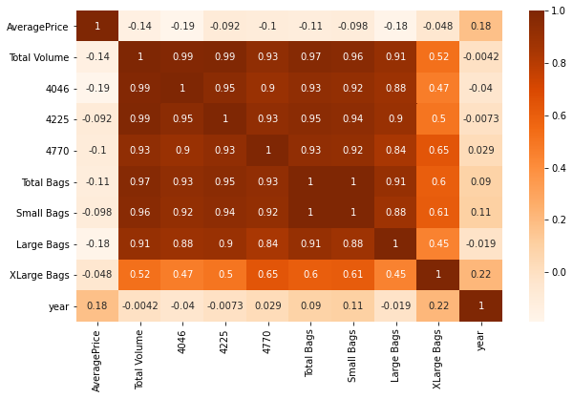

The correlation matrix does not indicate any high degree of correlation with the dependent variable. However, it does provide us with a holistic view off all the factors.

* As we can from the heatmap above, all the Features are not correlated with the **Average Price column**, instead most of them are correlated with each other. So now I am bit worried because that will not help us get a good model. Let’s try and see.
* First, we have to do some Feature Engineering on the **categorical Features: region and type**

# 3. EDA Concluding Remark.

* Find patterns of data through visualization and reveal the hidden trends from data.
* Using both matplotlib and seaborn library to visualize the data
* Finding relationships between features using bar graphs, histograms, box plots, heatmap
* Analysing both the numerical and the categorical columns separately

### * Data Loading and Description

* This data was downloaded and provided by Data trained academy website Avocado Board website in May of 2018 & compiled into a single CSV.
* Represents weekly 2018 retail scan data for National retail volume (units) and price.
* The dataset comprises of **1517 observations of 35 columns**. Below is a table showing names of all the columns and their description.
* The unclear numerical variables terminology is explained in the next section:

|  |  |
| --- | --- |
| **Features** | **Description** |
| Average Price | Its just a useless index feature that will be removed later |
| ‘Total Volume’ | Total sales volume of avocados |
| ‘4046’ | Total sales volume of Small/Medium Hass Avocado |
| ‘4225’ | Total sales volume of Large Hass Avocado |
| ‘4770’ | Total sales volume of Extra-Large Hass Avocado |
| ‘Total Bags’ | Total number of Bags sold |
| ‘Small Bags’ | Total number of Small Bags sold |
| ‘Large Bags’ | Total number of Large Bags sold |
| ‘XLarge Bags’ | Total number of XLarge Bags sold |

Here type will be the target variable.The dataset is well organised with no missing values Target class is imbalance.

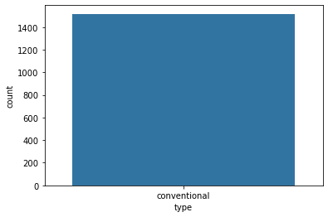

Here heat map contains the null values of the Dataset.

Below I am checking the null values, as find there are no null values in the data set because the red colour is distributed equally correspond to each column

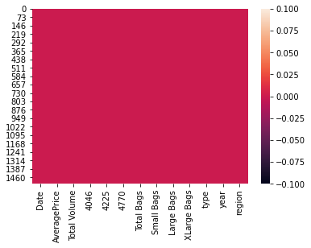

sns. pairplot(df)

Remove the missing values.

drop the nagativitycorrelated columns.

remove the outliers.

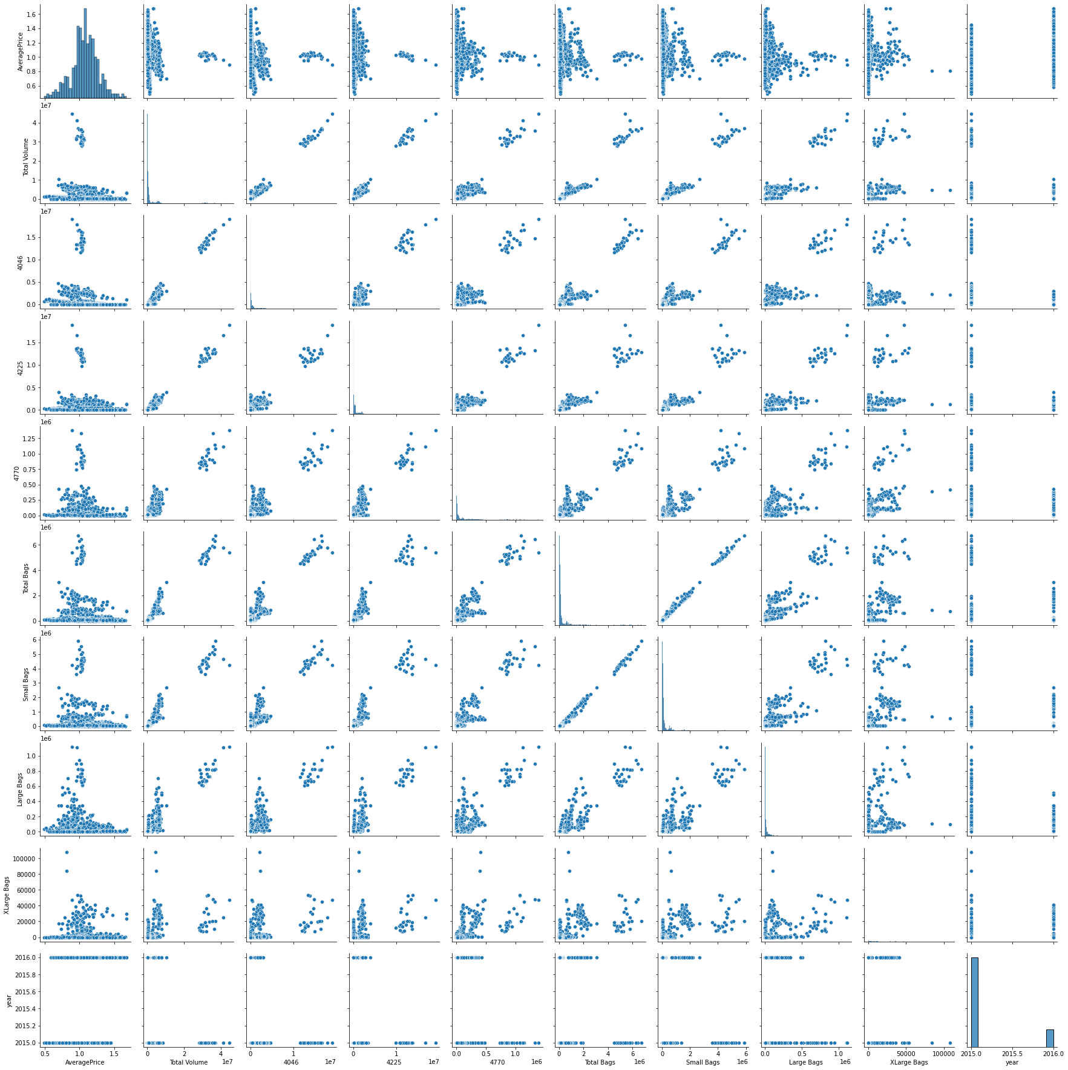

# 4. Pre-Processing Pipeline:

Encoding is used to create dummy variables to replace the categories in a categorical variable into features of each category and represent it using 1 or 0 based on the presence or absence of the categorical value in the record.

This is required to do since the machine learning algorithms only work on the numerical data. That is why there is a need to convert the categorical column into a numerical one.

For each of the transformations in Python that has a fit_transform() method , we can wrap them up in an actual pipeline that executes them all in order and even go back and view attributes of each of the transformations. Additionally, you can set parameters for each transformation and the syntax for that is in the link I just shared. If anything, using this pipeline has just cleaned up my code a lot and organized my thinking better.

Sklearn provides a very efficient tool for **encoding** the levels of categorical features into numeric values. **Label Encoder encode labels** with a value between 0 and n_classes-1 where n is the number of distinct **labels**. If a **label** repeats it assigns the same value to as assigned earlier .Convert Region and Type into numeric value by using encoder.

Data has to be pre-processed as machine learning models are better at reading numbers than words. Using label encoding, categorical data can be replaced with numbers. Below code is to display all categorical data.

**fromsklearn.preprocessingimport** Label Encoder

LE=Label Encoder()

df["year”] =LE.fit_transform(df["year"])

using the above label encoding method, categorical data can be replaced with number.

# 5. Building Machine Learning Models.

* let’s apply our model which is going to be the **Linear Regression because our Target variable 'AveragePrice' is continuous**.
* Let's now begin to train out regression model We will need to first split up our data into an **X array that contains the target variable**, and a **y array with the target variable**.

x=df. drop(["AveragePrice"], axis=1)

y=df["AveragePrice"]

x_train,x_test,y_train,y_test=train_test_split (x,y,random_state=50,test_size=0.2)

Here we can use Regression method to build the models

* + 1. DecisionTreeRegressor
    2. LogisticRegression
    3. RandomForestRegressor
* I had done this prediction by taking Average price as an output variable which is continuity in nature so that why I’m using the regression technique
* While calculating the best random state the 80 is best state which providing the highest R2 score value for this model.
* After using the GridSeachCV, I can find the best param and then I used these param for that model.
* There are following matrices which I find, and which are providing the best score.
* I also plot the scatter plot graph and we can see that the actual value and predicted values are very close to each other, so the line is best fit line.

Now I am finding the score by taking region as an y value, I am using Regressor method because the region data is categorical in nature, so I am importing the Regressor model and their matrices.

The highest final model of the dataset: In the end, we can see that utilizing data science on AveragePrice provided significant benefit to the business as we can tag each fruit with the averages price and come up with customized Avacado retention strategy for each group.

According to the Regressor report the accuracy of the model is 63% however its recall is lower at 15% of positive cases. The DecisionTreeRegressor model is providing excellent results, however the purpose of the problem is to identify fruits that are likely to leave. This is the reason that accuracy then becomes a very important measure. Accuracy measures the fraction of values that are identified correctly.

Decision Tree Classifier has emerged as the final winning model with 63% and highest. This could be the highest possible score achieved with the inherent limitations in the dataset. Here Decision Tree Regressor is the best model.

Machine learning models are as good as the data to feed it, and more data would strengthen the model. For example, in this dataset, the feature ‘Performance Rating’ has been restricted to scores of 3 and 4 only. More insights could be generated if the full spectrum of performance ratings is included. In the real-life situation, getting the right data is often more challenging than the analytics itself.

# 6. Concluding Remarks.

* With the help of notebook I learnt how **EDA** can be carried out using **Pandas and other plotting libraries**.
* Also, I have seen making use of packages like **matplotlib, plotly and seaborn** to develop better insights about the data.
* I have also seen how **preproceesing** helps in dealing with **missing values and irregualities** present in the data. I also learnt **how to create new features** which will in turn help us to better predict the survival.
* I also make use of **pandas profiling** feature to generate an html report containing all the information of the various features present in the dataset.
* I have seen the impact of columns like **type, year/date** on the **Average price increase/decrease rate**.
* The most important inference drawn from all this analysis is, I get to know what are the **features on which price is highly positively and negatively coorelated with.**
* This project helped me to gain insights and how I should go with flow, which model to choose first and go step by step to attain results with good accuracy. Also get to know **where to use Linear, Decision Tree and other applicable and required models to fine tune the predictions**.
* Random Forest Regressor model predicts the average price more accurately than linear regression model.
* In this project the trend and periodity of avocado price and sales volume time series and also analysed their association .we extracted monthly and annual patterns from the spectrum density analysis ,and also determined the trend of price variation from the spectrum decomposition ,which is not constantly increasing but shows a decreasing trend in recent years.in addition,we applied a regression on the price and sales volume time series and discovered a negative correlation between the two time series. Which is consistent with our empirical knowledge.
* The visualisation we were dreaming of at the beginning of this project has now become a reality.